Radiant Solar
BUSINESS CASE FOR A DIGITAL WORKPLACE ON OFFICE 365
Delivered through an Intranet Portal Structure

Table of Contents
1 Executive Summary 3
2 Current Situation 5
3 Recommended Solution 6
4 Implementation Impacts and Risks 8
5 Cost Overview 8
6 Stakeholders 9
7 Project Scope 10
8 Options Considered 12
9 Benefits Analysis 14
9.1 Return on Investment 15
9.1.1 Assumptions 15
9.2 Non-Financial Analysis 16
9.2.1 Benefits 16
9.2.2 Features 20
10 Appendices 21
Appendix 1 - NPV Table 21

Executive Summary
[Briefly outline the purpose of the business case and the benefits for the business. See example:]
Over the past 5 years, Radiant Solar has grown to one of the leading Solar Power providers for commercial customer in the western U.S. Now with over 200 employees and six locations in three states, we face the opportunity and challenge of putting in place a technology infrastructure that makes it easy for our employees to do business inside our company regardless of which internal department they are interacting with. Also, because we are in a competitive industry, providing a central place for information, communication, and sharing of knowledge for our distributed workforce is key to our successful growth.
However our current technology infrastructure could hinder growth, and negatively impact worker productivity. In the chaos of rapid growth we have added siloed departments each with their own procedures, policies and systems, many on different hardware and platforms, different security or sign-in schemes, separate maintenance procedures and separate recurring costs. Today we have 16 separate systems which provide internal services to our employees.
This model has the following impacts:
- Growing IT Costs: We keep adding new standalone systems. Each requires administration and maintenance, user ids for every employee, and recurring subscription or maintenance dollars.
- Lower employee productivity - employees spend to much time on administrative tasks and activities rather than focus on their job
- Lack of management visibility - little visibility of internal service departments productivity and service levels because of manual processes and standalone systems
- Chaotic Communications: No consistent way to communicate news, events, announcements, policies, procedures to employees except through email
- Limited Access: Offsite employees are required to VPN into systems, and there is little support for mobile devices.
All of this is symptoms of an “organic growth” IT strategy, which is a reaction to “need at the time” and a department driven approach which is common in many companies today. At this time in our growth and maturity as a company it is critical we make decisions that will support and not hinder growth and our competitive needs.
Proposed new approach
Advances in technology for small to medium businesses provide us with transformative opportunities leveraging a modern IT infrastructure. Cloud computing and the Office 365 allow us to step back and build upon a core platform which can be used as a next generation Digital Workplace infrastructure which can serve as an organizational hub for our workers. Today, we use Office 365 for email and document storage, but that is just scratching the surface of what the platform can be used for. Microsoft has architected it to go beyond MS Office in the cloud to become an organizational ecosystem platform for communication, collaboration and business process automation. We can build upon this platform by deploying an Intranet structure which provides a central hub for communications, employee engagement, and provides a consistent set of internal services from department such as IT, HR, Finance and Facilities. Additionally, it can support project tracking, document management and automate currently manual business processes.
This document outlines the business case for the implementation of an Intranet solution for Radiant Solar to create a central hub for our organization operations.
The benefits of this project are:
- Significantly lower IT costs due to reduction in hardware and software maintenance
- Higher employee productivity through streamlined business processes and self-service
- Better communications and collaboration with a central organization portal
- Improved management visibility on internal service department productivity
- Broadened system access for traveling and distributed workers
- Flexibility to support new growth initiatives in the future
Best of all unlike adding traditional systems, this approach actually can significantly reduce IT budget over time because it all runs on a platform we already have, administer and use, Office 365. We will be able to consolidate from XX separate systems into a new “Digital Workplace” the Intranet Structure on Office 365. We will use out-of-the-box applications from SP Marketplace to accelerate implementation and save costs. The cost of the package and services are $XX,XXX and will be implemented in three phases over 1 year.
Hard cost savings on just hardware, software and the cost to maintain the systems amounts to over $XXX,XXX per year. This does not take into account massive productivity gains by employees and department staff. Cost per year of the Intranet package averages out to $XXXX per year over 5 years. This represents an ROI of less than X months.

Current Situation
[Briefly detail the problems you are trying to overcome, the potential solution and the implications of doing/ not doing it. See example:]
As we have discussed in the Executive Summary above, Radiant Solar has no structure or central point for communications, collaboration and access to internal processes servicing the entire Radiant Solar business and locations. We have done some adhoc work building SharePoint team sites here and there. What exists is a loose arrangement of homepages bearing an array of links to internal systems and resources and external web sites, with little or no context or navigation how to find information.
In some cases, Departments do not have a presence on the Intranet, forcing them to manually fulfill repetitive requests for commonly used forms and information throughout the organization.
Those Departments that do have Intranet sites, do not follow any group technology or information standard, often using disparate web development tools that impede the ability to quickly and efficiently update and/or change information on the site.
The lack of a formalized Group approach to corporate and operational information and processes via a standardized Intranet platform is an efficiency opportunity lost to business operations.
The current infrastructure has the following impacts:
- Employee productivity: Accessing internal services can time consuming for employees to find what they need and frustrating because they have to access multiple systems which require multiple sign-ins and user interfaces for core business processes.
- Management Visibility: With disparate systems, it is very get a picture of department productivity. HR has requested another resource, how do we measure the need? Are lost requests for credit checks to finance impacting sales? How quickly does IT resolve issues? Internal services productivity impact all aspects of the company and there is no visibility into performance.
- Chaotic Communications: With a distributed workforce, how do we communicate news, alerts, or the latest industry news? If through email, do all employees see it? Did it get lost? Where do they find the latest time-off policy? How do we build our culture, get executive perspectives out to employees? We have no central place or process for communications.
- Limited Access: Many of our systems are still on servers housed at one location and require VPN to access them. Very few of the systems provide mobile device support or if they do, each is implemented differently for the type of device.
- Growing IT Costs: We keep adding new standalone systems. Each requires administration and maintenance. Another userid for every employee, separate back-up, storage management and recurring subscription or maintenance dollars. Plus, because of lack of integration, re-keying data between systems takes time and is error prone.

Radiant Solar is suffering loss of productivity as employees are forced to search, often manually, via word of mouth or email, for information. Additionally when using operational processes such as time-off requests, travel requests or expense submittal they need to sign-in to multiple sysetms and learn multiple user interfaces to successfully complete the business process. For those processes requiring approval, their managers face the same hurdles. Similarly, the departments providing services (HR, IT, Finance etc.) are resorting to resource-intensive manual methods to manage requests for and receipt of standard forms and other requirements from their customers – the employee.
Organizational Intranets are now an accepted method of providing efficient and cost effective access to information and processes for the purpose of running a business. The Radiant Solar organization is currently denied this time and resource saving opportunity.

Recommended Solution
[Briefly outline the recommend solution, its benefits and the rollout approach. See example:]
Radiant Solar has the platform, which can be built upon to solve this problem. It is Office 365 and SharePoint Online in the cloud. Today we underutilize Office 365 by using it only for email and limited document storage. It has all the underlying structure to create an Intranet structure. However, to be usable by employees and meet our specific requirements, we will need to build a full solution, contract to have it built or deploy an out-of-the-box solution on top of Office 365. After a comparative analysis, from a financial and resource perspective realistically we should clearly pursue the out-of-box solution which we can modify to our needs.
It is proposed that a system called SP Business Suite which is an out-of-the-box set of portals and applications which provide an Intranet Structure at the corporate and department levels be purchased. It can run on our existing Office 365 platform and requires no additional investment in infrastructure. The following modules are available in the solution structure. After purchasing the initial Intranet Package (in red), we can add other modules as it makes sense.
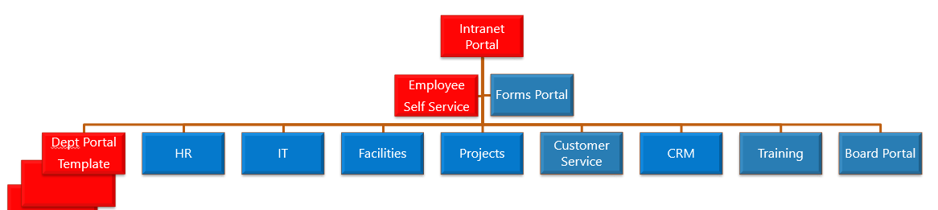
It is proposed we purchase the components needed for Phase I :
- SP Intranet Portal – includes Home Page, Employee Self-Service and three departments
- SP IT Support module
- SP HR Module

- Quick Start Service – Installation, setup and basic training
- Customization hours – a set of customization hours to modify the solution to our needs
Additionally we may want to consider additional modules for Projects, Facilities, Sales and Board of Directors after the model has proven itself for future phases.
The product is built on Office 365 SharePoint Online and is native part of the Office 365 Ecosystem. It is 100% no-code customizable by business power users to we can modify the modules to fit our needs. It requires no additional hardware or software to deploy the product.
Best of all it will fully integrate with other Radiant Solar technology initiatives such as Active Directory, MS Office Suite and Corporate Directory.
SP Business Suite offers Radiant Solar one consolidated platform on which to manage online processes and internal communications. It will enable us to deliver an all in one Intranet or portal with extranet capabilities if desired (e.g. for retail stores or suppliers).
Within a relatively short implementation timeframe a company-wide Intranet can be deployed, with on-demand project team workspaces, and customizable department subsites. Radiant Solar will be able to easily customize/ configure the system to our business requirements.
It has the most user-friendly interface from the products reviewed and will consequently require minimal training for the administrators. In addition, the built-in statistics reporter will enable us to monitor the growth and success of the site.
We will be able to centralize information in an easy to use, intuitive, organized, shared, and fun environment, which improves productivity, decision making and increases employee satisfaction.
SP Business Suite from SP Marketplace, is a US product used by more than 700 companies worldwide; a detailed description and customer listing can be found at the following address: www.spmarketplace.com/
The product is built on Office 365 SharePoint Online and is native part of the Office 365 Ecosystem. It is 100% no-code customizable by business power users to we can modify the modules to fit our needs. It requires no additional hardware or software to deploy the product.

Implementation Impacts and Risks
[Outline any potential risks in relation to implementing a new Intranet within the organisation. See example:]
The main implementation impacts and risks that have been identified will largely be related to the time spent by our team to receive training, migrate content and to transition to the new system. We will need to appoint a resource (part time) as the application administrator. There will also be adjustments for end users as they become accustomed to the new Intranet site.
Key risks associated with the project include:
- Little or no leadership by C-level management to make this a priority could result in delays or failure of the project
- A lack of ownership of the Intranet home page and department content, resulting in stale information that impacts user adoption
- Organizational resources not being in place to provide the vender specific requirements during with the implementation.
- End user confusion during the transition to the new structure.
All of these risks are related to our “readiness” to take responsibility for working with the vender to implement the new system. While no one person is required as a full time resource for this project, multiple departments will need to work together for it to be a success.

New System Cost Overview
[Provide “High Level” costs associated with the project for Year 1, annual and 5 year Total Cost of Ownership]
Technology Costs

The funds required to implement Phase 1 of the Intranet project are US$20900 (apply

Product / Service | Initial Cost | Annual Cost | 5 Year TCO
Intranet Package | 5000 | 1000 | 9000
IT Support | 2800 | 575 | 5100
HR Portal | 4200 | 875 | 7700
Projects | 4200 | 875 | 7700
Board Portal | 2700 | 575 | 5100
Customization Services | 2000 | 0
 |  |  | 0
Additional O365 Sub | 0 | 0 | 0
Additional Hardware | 0 | 0 | 0
Total Costs | 20900 | 3900 | 36500
Personnel Costs

Radiant Solar personnel required for this project are:
- Application Administrator – estimate 8 hours per week during the project (up to 80 hours), then 1-2 hours per week ongoing at most.
- Department Managers – requirements definition and site review 6 hours
- Department Admins – 3 hours for project. 1 hour per week ongoing for content update
- Employees – 1 hour for training sessions

Rough estimate for all but employees above - $5000 in personnel costs for the project.

While these estimates are directly related to the project and maintaining the solution, they are offset greatly by productivity gains.

Stakeholders
[This table represents the different groups associated with the project and their role initially and ongoing. See example:]
Group | Function
Executive Team | Financial sponsor for the project
Communications Team | Responsible for overseeing the Intranet as a whole and maintaining the global home page.  Will use the Intranet to access information
MIS & Technology | Office 365 administration and owner of the IT support Portal
HR | Will use SP Bus Suite to administer the HR portal site.  Will use the Intranet to access information
Operations | Will use SP Bus Suite to administer the Operations Portal site.  Will use the Intranet to access information
Sales & Marketing | Will use SP Bus Suite to administer the Sales portal sites.  Will use the Intranet to access information
Research & Development | Will use SP Bus Suite to administer the R&D Portal sites.  Will use the Intranet to access information

Project Scope
[Define the scope of the project. What is to be achieved initially and then 6, 12, 24 months down the track. The aim here is to put some boundaries around what can realistically be achieved given time, resource and financial realities. See example:]
It is recommended that the new Intranet be introduced in a phased approach. This document presents the business case for Phase 1 and Phase 2 of the Intranet project. Phases 3 and beyond will need further analysis as to requirements and work required.
The phases are as follows:
Phase 1 – involves creating the base Intranet structure on Office 365 SharePoint and includes:
- Intranet Portal Home
- Employee Self Service
- Human Resources
- IT Support
- Finance
The aim is to consolidate as much Intranet information as possible within the one system. Each Department will be able to take advantage of appropriate tools that are available ‘out of the box’ with SP Bus Suite. Phase 1 of the project is expected to be completed by DD/MM/YYYY.
The above Departments were chosen for inclusion in Phase 1 of the project due to their obvious overall presence across all of the Radiant Solar operations. They provide ‘backbone’ services to the retail, commercial and corporate businesses and have the greatest need for an Intranet presence. The creation of these sites and an overall central homepage will provide a major benefit to these businesses via ease of information access and access to whole company relevant communication and information.
Phase 2 – involves using the structure established in Phase 1 to roll out SP Bus Suite to the remaining Departments including
- Operations
- Safety
- Sales & Marketing
- Research & Development

Phase 3 – involves reviewing the site after 12 months to identify improvements that can be made at the Department level. Depending on other projects within Radiant Solar, additional functionality/systems may be made available through the Intranet.

Benefits Analysis and ROI
[In this section outline the major benefits of the Intranet project. Consider such items as:
The benefits possible from this change will be substantial over a five year period. Because what we are doing is changing the way we think about supporting systems, how they are bought, maintained and used. We divide the benefits analysis into “direct benefits” and “indirect benefits”. Direct benefits are easier to quantify with real dollar savings versus indirect which are often tied to employee and staff productivity time savings. Other indirect savings are reduction in risk as well. The following business case measures the before and after costs and benefits in the form of Total Cost of Ownership (TCO) along with productivity and competitive advantage benefits to the business in the future. We also break out cost savings into Hard Cost Savings - Direct budget impacting items like Hardware, software and IT Staff costs; and Soft Cost Savings - indirect savings like employee and staff productivity (time). Other benefits like risk avoidance, competitive advantage and employee moral are mentioned but not measured.
Direct Benefits – Hard Cost Savings
The direct benefits of this project are tied to streamlining processes and consolidating systems which we term “Hard Costs”. Hard Costs include the platorms and software that comprise your current internal services infrastructure vs. the proposed new infrastructure. When evaluating the Total Cost of Ownership, there are three main elements to take into account: Acquisition cost, Implementation cost and Support/Maintenance cost.
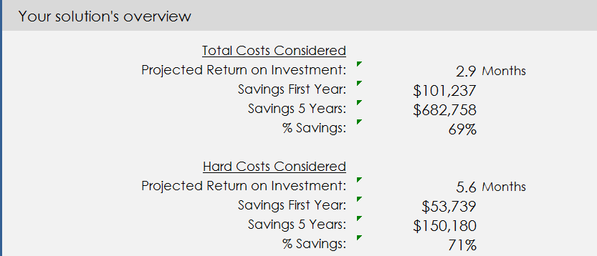
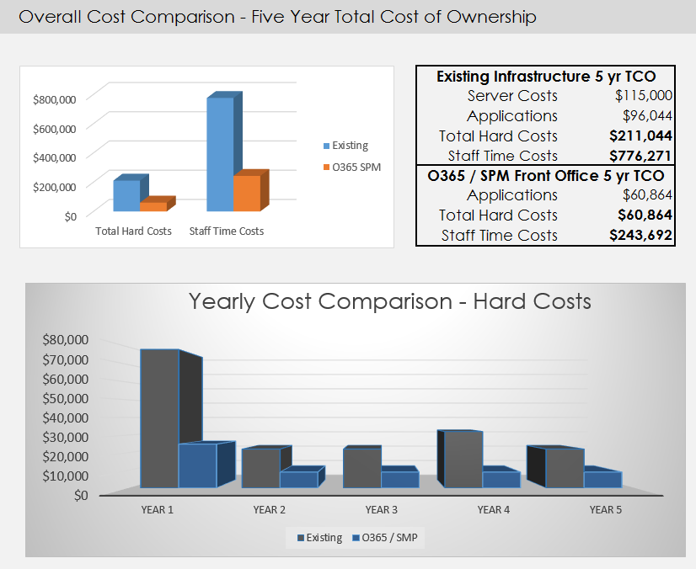
Indirect Benefits - Soft Costs
Employee and Staff time and thus productivity is the primary measure of soft costs. It is the measurement of time spent away from their primary duties doing administrative or internal service related activities.
- Time savings for repetitive tasks. For example
  - Finding, completing and submitting forms
  - Locating the latest version of documents
  - “On boarding” new staff. ie. Staff induction
  - Accessing business applications to perform a business process
  - Answering frequently asked questions over phone/email
  - Finding staff contact details
  - Keeping staff up to date with changes to policies and procedures
  - Submitting and tracking service requests
  - A consistent way for corporate announcements, alerts and events to reach employees.
Insert the Time Savings Comparison here from ROI Worksheet.

Non-Financial Analysis
[In this section outline the intangible benefits of implementing a new Intranet. Also provide an outline of the features of the software]
Beyond the calculated savings above our organization will benefit from numerous residual benefits of moving to a new front-office technology infrastructure. The following lists those additional benefits:
 |  | Feature | Existing | O365 SPM
 | Flexibility |  | minimal | high
 | Integration |  | minimal | high
 | Mobile Support |  | No | TES
 | Remote Accessibility |  | NO | YES
 | Central Documents |  | NO | YES
 | Empower Employees |  | NO | YES
Always Current Technology |  |  | NO | YES
 | Central Hub for Organization |  | NO | YES
Management Visibility |  |  | NO | YES
 |  | Single Platform | NO | YES

Specific Functional Benefits
[Expand on the benefits most important to your business. Try and give concrete examples of where you can see a process that needs improving]
Other foreseeable benefits include improvements to the following areas.
Non-financial Benefits | Description | Stakeholder(s) Impacted
Employee productivity and morale | - Build corporate community and culture. Provide interactive tools to bring people together. Present a consistent internal face of the organization to your employees.  - Allow feedback functionality to create a two-way communication flow between employees and management.  - Social networking within the Enterprise.  - Help to improve employee satisfaction and increase employee retention.  - Empower staff to contribute knowledge and information.  - Foster collaboration through dedication secure project workspaces and community tools such as the forum and staff offers.  - Increase company brand awareness through consistent messaging, Intranet branding to your company’s colors and imagery.  - Create a designated one-stop-shop, for internal communications that is easy and consistent.  - Empower employees with the latest and most up-to-date company communications.  - Announce company achievements like sales wins, project completions and employee recognition.  - Streamline policy and procedures and assist in compliance through your tailored online processes.  - Improve and streamline day-today administrative tasks via the Intranet.
Sales Portal | - Create a hub for sales and marketing staff to share sales resources and marketing assets.  - Make reports accessible through dashboards.  Portal for up to date industry news and competitive information to keep staff up to date and competitive  - Central place for sales quotes, contracts, proposal documents
Marketing and Communications | - Service request system for website changes requests, marketing resources and programs, internal store items, marketing services.  - Track marketing projects like campaigns, collateral development, social networking, etc.  - Marketing Calendar to track campaigns, events etc.  - Document libraries to track collateral, presentations, contracts etc.  - Track Venders and performance  - Keep employees apprised of latest Marketing activities, tweets, news etc.
Projects | - Create secure spaces for projects with a document sharing, issue tracking and idea exchange to facilitate and manage deadlines and work. Re-use information from past projects and avoid having to reinvent the wheel.  - Provide the most up-to-date information to all project members, regardless of location.  - Provide Project roll-up information for Management
Human Resources | - Improve service with Service Request tracking  - Move HR processes and forms online  - Automate hiring, onboarding and policy management.  - Manage and track performance reviews  - Give employees a one-stop-shop to find the resources they need with a MyHR portal.  - Bring in other HR functional systems into the consistent look  and feel of the Intranet.  - Improve employee engagement and retention.  - Manage Employee documents
Facilities | - Track maintenance schedules and location of assets across facilities  - Provide a MyFac Portal for employees  - Automate the work order tracking process  - Provide access to documents, floorplans, Office assignments etc.
Standards & Quality Assurance | - In-built audit tracking.  - Bring all your documents and procedures online so they are easy to find and easy to access by anyone that needs them. Add consistency across departments in how procedures are developed and communicated. (Compliance)
Investor & Board Communications | - Create secure environments to communicate with investors or board members.  - Eliminate printing out meeting documents. Make them available online.
Information Technology | - Provide a single platform rather than many  - Reduce time spent on maintenance and administration. Reduce IT burdens, giving IT staff less “reactive” tasks and allow them to concentrate on other strategic activities.  - Consolidation of infrastructure by reducing the number of servers and databases required to run business applications  - Leverage any existing MS infrastructure and your Active Directory profiles.  - Deliver mobile support in a single platform rather than retrofitting many legacy applications  Achieve fast deployment with ease of installation

Appendices

Appendix 1 – Business Case Worksheet inserted here.

