FOR IMMEDIATE RELEASE
May 2, 2017

Ashley Johnson
(408) 497-7255
ashleyj@spmarketplace.com
www.spmarketplace.com

SP Marketplace Releases SP Marketing Portal for Office 365
Manage and track all aspects of Marketing in one place, with a Digital Workplace solution
Sacramento, CA -- SP Marketplace (www.spmarketplace.com), the leader in Office 365 and SharePoint business portals and applications, has released SP Marketing Portal, a next generation business solution that allows marketing staff to manage the entire marketing department from a single portal. Whether tracking marketing plans, social media, campaigns, collateral, marketing services requests, administrative management, or website changes and SEO, SP Marketing Portal provides a central point for management, collaboration, resources, and services on Office 365 and SharePoint.

More than just a marketing automation tool
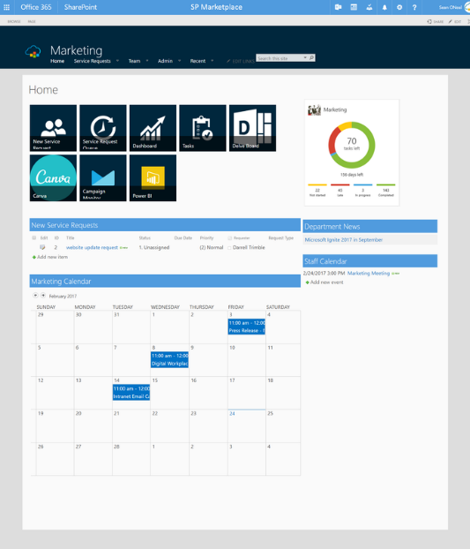
Traditionally, marketing staff uses many separate automation tools that only support one aspect of marketing. But tools alone are not enough. SP Marketing Portal brings all areas of marketing together in a new approach that manages the entire marketing process.
With SP Marketing Portal you can track and manage:
- Events and campaigns
- Collateral and resources
- Social media content and programs
- Marketing media, images, and templates
- Website development, changes, and analytics
- Projects, tasks, and calendars
- Requests for marketing services

From marketing administration to marketing development to measuring and tracking results with a central dashboard, SP Marketing Portal works with automation tools to address all aspects necessary for a successful marketing department down to the most minute details.
While other marketing automation solutions focus solely on individual tasks like social media and email campaign delivery, SP Marketing Portal allows the marketing team to manage and address key marketing functions, such as service request tracking and marketing management, from a single portal that ultimately contribute to the overall success of the marketing department.

A single portal for the entire marketing group
Unlike the multitude of marketing tools and services that require separate logins, profiles, and workspaces for different team members that can inhibit collaboration, SP Marketing Portal is designed with the entire marketing team in mind so they can work together in one virtual central location.
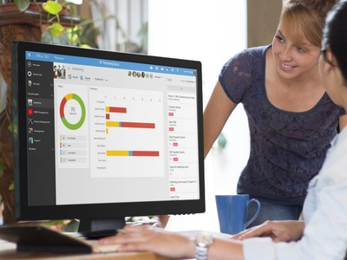
By leveraging the strengths of Office 365 and SharePoint, SP Marketing Portal allows the marketing group to collaborate online, even if they are in separate locations. From the staff portal, the marketing team can discuss current campaigns and projects with Groups, hold meetings over Skype for Business, assign and view marketing tasks with Planner, or create and manage videos.
For individual team members of the marketing department, SP Marketing Portal features a separate space within the portal called My Workspace. Here employees can see tasks and service requests assigned to them. They also can access commonly used links or applications, such as OneDrive, Planner, Teams, calendars, and more.
Within SP Marketing Portal, the marketing team can link directly to tools like MailChimp, Hootsuite, Facebook, or Twitter without having to open a new browser.
By addressing key functions like website management, marketing service requests, web forms, mailing lists, and more, SP Marketing Portal presents an entirely progressive, innovative approach to the marketing management process that has never been seen before.
By integrating with Power BI, the marketing team can analyze their marketing efforts through web traffic, searches, links, traffic sources, bounce rates, and goals while automatically linking from a single dashboard using Google Analytics or other web metrics tools.
A resource for the entire organization
SP Marketing Portal is not just for the Marketing department but addresses other relevant departments, too like Sales, Customer Services, and more.

With the MyMarketing Service Portal, internal customers like the Sales team or executive management can immediately access key marketing collateral. Whether it’s the latest blog, datasheet, press release, whitepaper, customer story, webinar, or other marketing resource, it’s all located in a secure, central location.

If a document or resource is not available, internal customers can submit a service request and track its status while also receiving automated notifications. Additionally, they can see marketing announcements and events, or access the marketing calendar to see what campaigns are approaching to customize their sales strategies.

SP Marketing Portal is available today and starts at $2,500 for businesses up to 300 employees.

About SP Marketplace
Founded in 2012, SP Marketplace is the leader in business solutions and Operational Portals that transform Office 365 and SharePoint into a Digital Workplace. Installed at over 1000 businesses worldwide, SP Marketplace Digital Workplace Solutions unify SharePoint and Office 365 into a consistent user experience that drives collaboration and automates core business processes. To learn more, contact Ashley Johnson at ashleyj@spmarketplace.com or visit www.spmarketplace.com.

###

