FOR IMMEDIATE RELEASE
March 14, 2017

Ashley Johnson
(408) 497-7255
ashleyj@spmarketplace.com
www.spmarketplace.com

SP Marketplace Offers Free Intranet Solution on Office 365 - SP Intranet Portal
SP Intranet Portal is included free with any operational portal as an anchor to a Digital Workplace

Sacramento, CA -- SP Marketplace (www.spmarketplace.com), the leader in Office 365 business portals and applications, has announced that it is giving away its Intranet solution SP Intranet Portal with the purchase of any of its Operational Portal offerings. An Intranet portal is the start to a Digital Workplace portal structure that brings organizational context to Office 365 and SharePoint where businesses can redefine productivity.
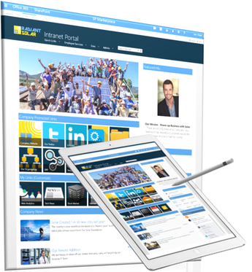
Unlike other vendors that only provide an Intranet, SP Marketplace uniquely goes beyond an Intranet to deliver a full operational portal structure through its integrated SP Digital Workplace Solutions, which includes SP Intranet Portal, department portals and business applications. SP Intranet Portal is an out-of-the-box solution that provides an easy-to-use and intuitive home page that serves as a central point for organizational communication and collaboration.
By offering SP Intranet Portal free with any purchase of an operational portal within SP Digital Workplace Solutions, SP Marketplace is helping businesses to create a complete Digital Workplace Structure. When combined with SP Digital Workplace Solutions, SP Intranet Portal provides an anchor to a Digital Workplace.
SP Intranet Portal acts as an organizational hub that, when combined with operational department portals, opens the door to a Digital Workplace on Office 365 and SharePoint. Employees and managers can communicate and collaborate effectively, consistently, and cohesively.
“Going beyond an Intranet to a full Digital Workplace is core to redefining productivity at a business. We have seen this succeed with hundreds of customers,” said Darrell Trimble, CEO of SP Marketplace. “We want to see businesses kick-start their Digital Workplace strategy with the Intranet as the anchor, so we are offering it free with any of our operational portals that are purchased.”
Out-of-the-box Intranet integrated into the Digital Workplace
SP Intranet Portal is a full featured out-of-the-box solution that is built natively on Office 365 and SharePoint. Designed as a part of a Digital Workplace, SP Intranet Portal seamlessly integrates with Office 365 services, such as Skype for Business and Yammer to chat live and hold discussions and online meetings.
It goes even further to leverage services like People, Delve, Groups, Blogs and more. For business communications, SP Intranet Portal makes it quick and easy to communicate company news, announcements and events. Users can personalize SP Intranet Portal how they want with optional content targeting. The MyLinks feature allows users to select personalized icons that link to their favorite and most used content, applications, or websites.
As part of the integrated SP Digital Workplace Solutions structure, SP Intranet Portal and Operational Portals such as HR, IT, or Facilities, deliver a consistent design and a common user experience. Additionally, integration across the structure allows for a unique Active Content feature so departments can automatically push important announcements, events and news, up to SP Intranet Portal to ensure content is always current.
And with all of SP Marketplace Operational Portals and applications, SP Intranet Portal is no-code, 100% customizable, and easy to administer.
Get your free SP Intranet Portal today and jumpstart your way to a Digital Workplace.

About SP Marketplace
Founded in 2012, SP Marketplace is the leader in Office 365 business solutions and Operational Portals that transform Office 365 and SharePoint into a Digital Workplace. Installed at over 1000 businesses worldwide, SP Marketplace Digital Workplace Solutions unify SharePoint and Office 365 into a consistent user experience that drives collaboration and automates core business processes. To learn more, contact Ashley Johnson at ashleyj@spmarketplace.com or visit www.spmarketplace.com.

###

