FOR IMMEDIATE RELEASE
February 28, 2016

Ashley Johnson
(408) 497-7255
ashleyj@spmarketplace.com
www.spmarketplace.com

SP Marketplace Releases Digital Workplace Solutions for Office 365
Next generation Operational Portal Solutions unify SharePoint and Office 365 services to deliver a Digital Workplace
Sacramento, CA -- SP Marketplace (www.spmarketplace.com), the leader in Office 365 business portals and applications, has released SP Digital Workplace Solutions, a next generation collection of Operational Portals and business applications that transform Office 365 into a unified Digital Workplace for employees to work more effectively.
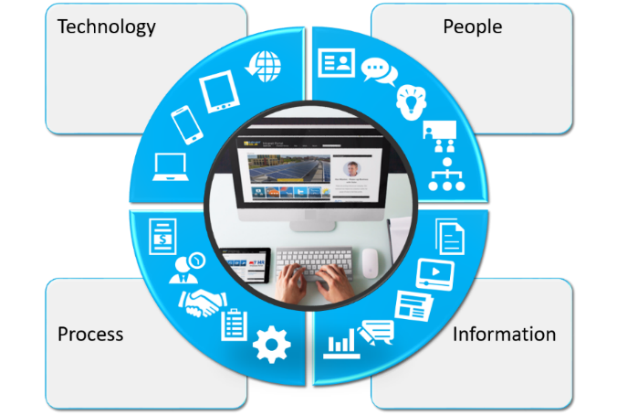
SP Digital Workplace Solutions builds on the success of SP Business Suite, anchored by SP Intranet Portal and used by more than 1000 businesses around the world.

Empower employees, consolidate services, and reduce complexity
SP Digital Workplace Solutions are an integrated set of Operational Portals anchored by an Intranet with departments, bring together collaboration, communication, and processes to deliver an intuitive Digital Workplace within the context of your business. Portals and applications built on SharePoint integrate with powerful Office 365 services to deliver a common user experience on a single platform.
“Many businesses have grown organically through siloed departments, which has resulted in a chaotic and complex IT infrastructure that is frustrating for employees and inhibits productivity,” Trimble said. “The concept of a Digital Workplace provides the opportunity to step back and consolidate processes and operations to a single platform, resulting in a simpler employee-facing IT infrastructure that provides a consistent way for employees to communicate, collaborate, and access internal services. SP Digital Workplace Solutions on the Office 365 platform move a Digital Workplace from concept to reality.”
Designed and built on native Office 365 and SharePoint
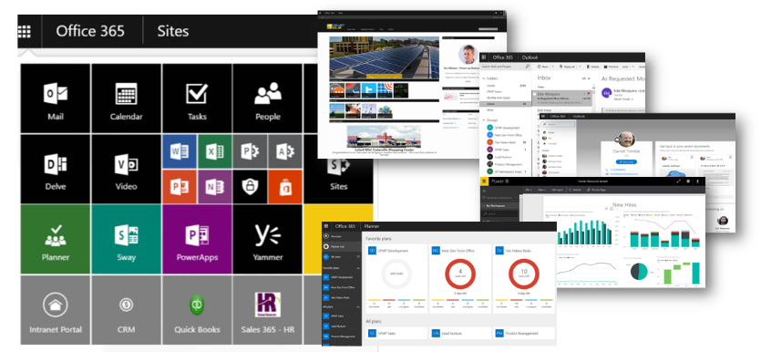
SP Digital Workplace Solutions are built natively on Office 365 and SharePoint. Unlike traditional business applications built on their own platform, they are no-code solutions that are 100% customizable by power business user. The user interface design follows Microsoft’s Office 365 look and feel to deliver a common user experience across Operational Portals and Office 365 services like email, Groups, Planner, OneDrive, Power BI and other services. Because they are native, powerful communication services like Skype for Business and Yammer are a seamless part of the Operational Portal experience. Integration with back office systems leverages Office 365 connectors and flow.
“By strictly adhering to a native platform development approach, our Digital Workplace Solutions benefit immediately from every new and future service that is available in Office 365,” Trimble said. “Additionally, because the Office 365 platform is constantly changing, by using native platform services for user management, security, and administration, our products experience no issues when Microsoft updates the platform each month.”
Packaging designed to allow “evolution” to a Digital Workplace
While SP Digital Workplace Solutions provide an integrated Operational Portal structure anchored by an Intranet, they can be purchased separately. This allows organizations to deploy the solutions in phases. The solutions include Intranet Home, Employee Self-Service and Operational Portals for HR, IT, Marketing, Facilities, Sales, and Projects. Additionally, a generic Operational Portal template is offered for other functional areas. Integrated process applications include a Central Help Desk, IT Support, HR Employee Tracking, Work Orders, Time Off, and much more.
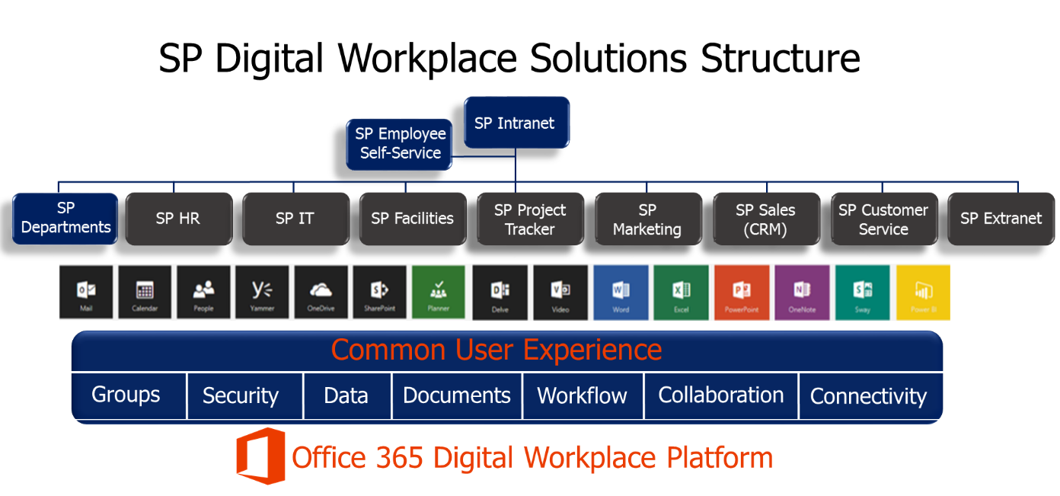
SP Digital Workplace Solutions run on Office 365 and SharePoint 2013 and above. Using the Quick Start Service, they can be deployed in as little as two business days from the day an order is placed.

Pricing is based on an annual subscription and organization size (number of employees). A base Intranet, self-service, and a couple departments starts at $6000 for the out-of-the-box deployment (300 person organization). Full suites start at $12,000. SP Marketplace also offers services for business transformation consulting and customizations. Customers can also take full control of their customizations with DIY Academy Training services for Business Power Users.

About SP Marketplace
Founded in 2012, SP Marketplace is the leader in Office 365 business solutions and Operational Portals that transform Office 365 and SharePoint into a Digital Workplace. Installed at over 1000 businesses worldwide, SP Marketplace Digital Workplace Solutions unify SharePoint and Office 365 into a consistent user experience that drives collaboration and automates core business processes. To learn more, contact Ashley Johnson at ashleyj@spmarketplace.com or visit www.spmarketplace.com.

###

