FOR IMMEDIATE RELEASE
March 21, 2017

Ashley Johnson
(408) 497-7255
ashleyj@spmarketplace.com
www.spmarketplace.com

SP Marketplace Announces Employee Central on Office 365
SP Employee Self-Service Portal serves as a central place for employees to access documents, services, and processes

Sacramento, CA -- SP Marketplace (www.spmarketplace.com), the leader in Office 365 business portals and applications, announced SP Employee Self-Service Portal (ESS), a portal solution on Office 365 designed specifically for employees to access documents, services and processes in a central place.
For employees, it eliminates time-consuming searches and frustration when dealing with inconsistent processes and ways to get services from siloed functional departments. SP ESS Portal is part of SP Digital Workplace Solutions as an integrated suite of portals and business applications that turn Office 365 into a Digital Workplace.
As part of a Digital Workplace, SP ESS Portal is the operational complement to SP Intranet Portal, which as a central point for communications and collaboration, acts as an organizational hub for services, resources, and processes from departments, such as HR, IT, Administration, or other internal service functions.
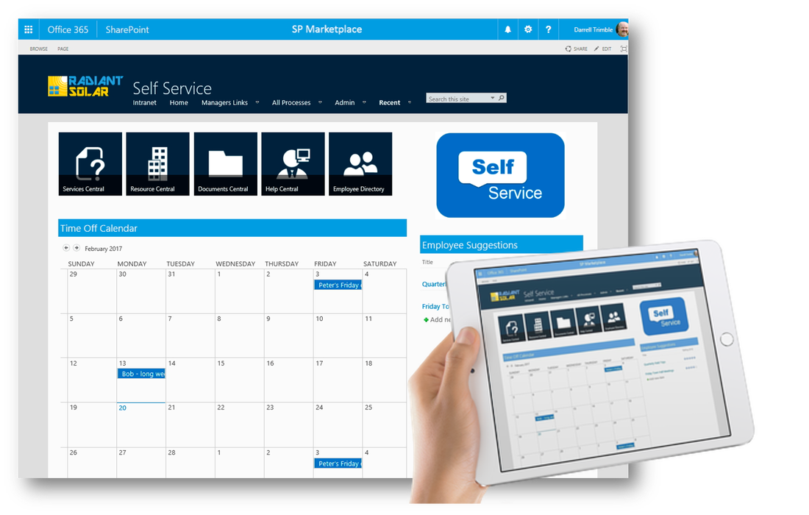
Linked to the Intranet Home, employees enter the self-service home page to access three main areas:
- Document Central
- Help Central
- Process Central
Instead of searching endlessly for policies and documents, sending emails, chasing requests with no response, or signing into many different applications to get what they need, employees access the portal from within Office 365 and everything is at their fingertips, whether they are in the office or working remotely.
With Document Central, employees have their own digital filing cabinet that they can search as precisely as they want, whether it is an HR policy, an IT procedure or the latest company positioning statement, it can be accessed easily using search or browsing of libraries.
With Help Central, employees can easily and quickly submit a request for service, in a consistent way across functional departments. Whether the request refers to a computer issue, an HR benefits change, or a maintenance fix from Facilities, it can be submitted from Help Central and tracked there as well. There is no need to sign into different help desk systems or chase internal service staff around by phone or email.
Finally, Process Central provides a central place to access employee-facing processes like time off, expenses, travel requests, or other business processes. Employees can access electronic forms in the forms catalog, fill out and submit to a common approval process, or they can access existing applications through links.
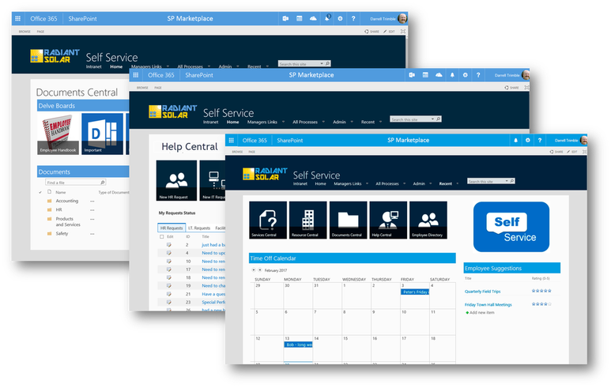
Because SP ESS Portal integrates seamlessly with Office 365 and the operational portals that make up SP Digital Workplace Solutions, it becomes a natural part of an employee’s workday. Additionally, productivity is dramatically increased in internal service departments by driving self-service and a consistent service structure. SP ESS integrates with SP Marketplace operational portals, such as HR, IT, Facilities, Marketing and others, routing service requests, forms, and documents between them.
SP ESS Portal is available today starting at $2,500 and ready to deploy in a matter of weeks. When you purchase SP ESS Portal, you also get SP Intranet Portal at no cost.

About SP Marketplace
Founded in 2012, SP Marketplace is the leader in Office 365 business solutions and Operational Portals that transform Office 365 and SharePoint into a Digital Workplace. Installed at over 1000 businesses worldwide, SP Marketplace Digital Workplace Solutions unify SharePoint and Office 365 into a consistent user experience that drives collaboration and automates core business processes. To learn more, contact Ashley Johnson at ashleyj@spmarketplace.com or visit www.spmarketplace.com.

###

